NAME :-ANANT HON
2124UMLM2029
4)Create a Table with Constraints
a) Create an EmployeeDetails table with EmployeeID as the PRIMARY KEY and DepartmentID as a FOREIGN KEY referencing a Department table. 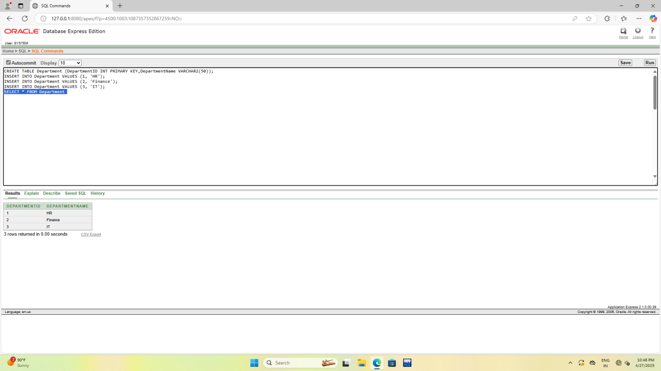
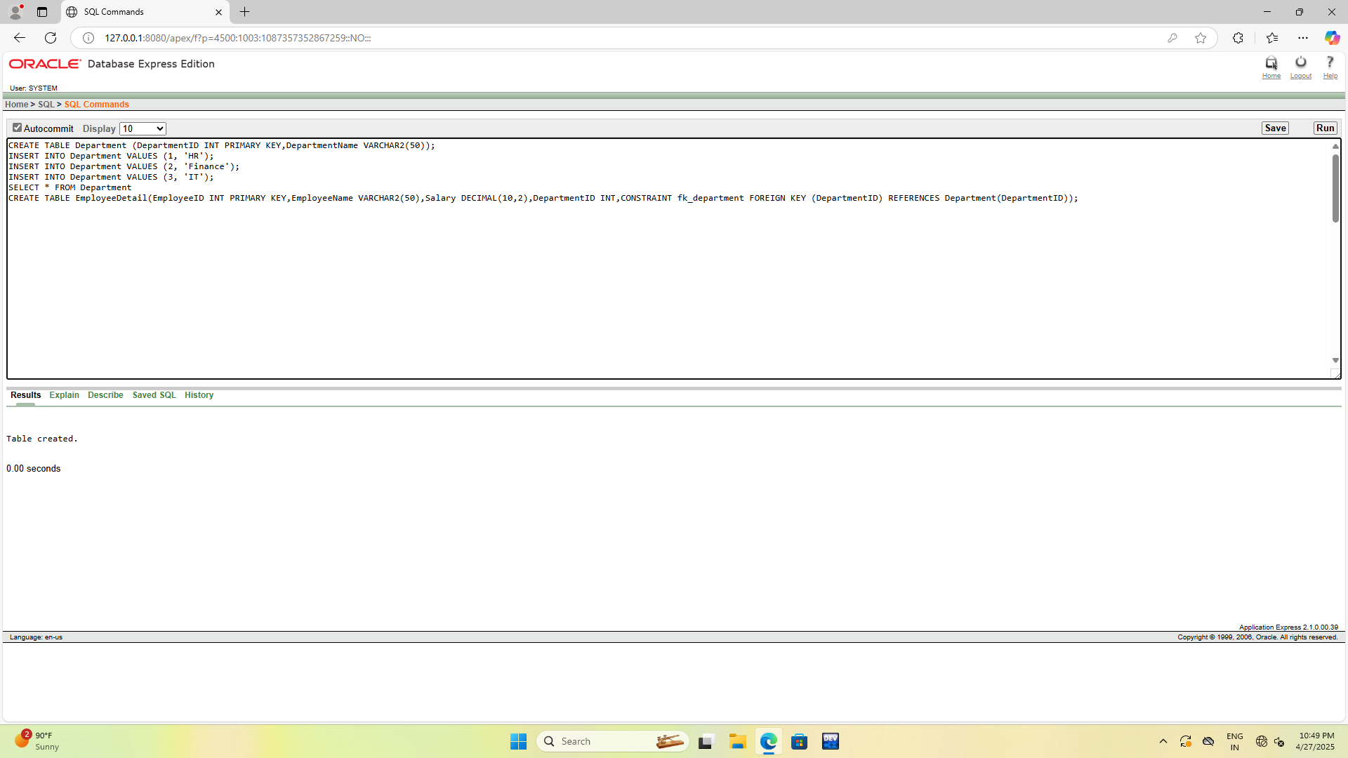

b) Insert a valid employee record with an existing DepartmentID, then attempt to insert an employee with a non-existent DepartmentID and observe the constraint violation.

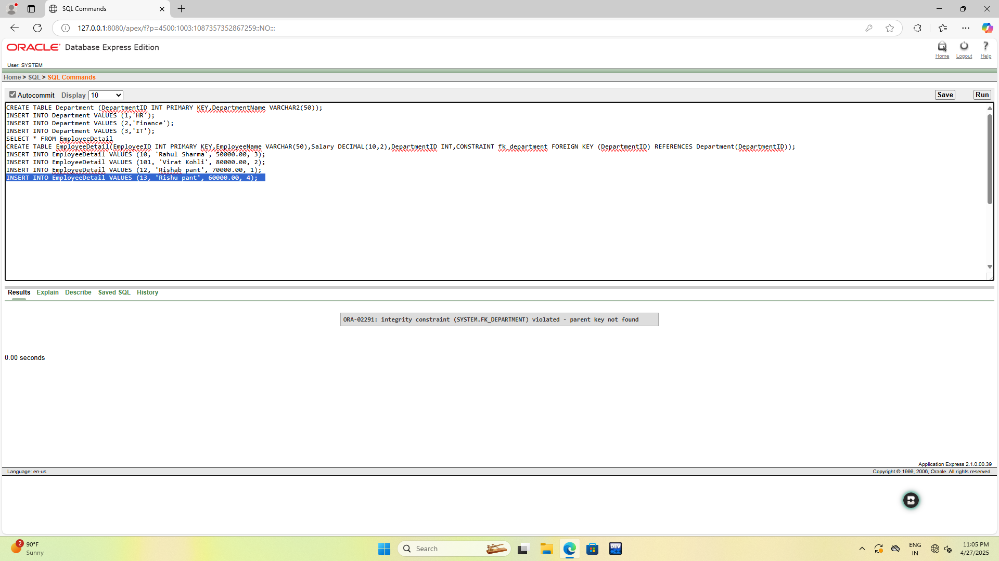
c) Insert an employee with a duplicate EmployeeID and check how the primary key constraint prevents duplicate entries. 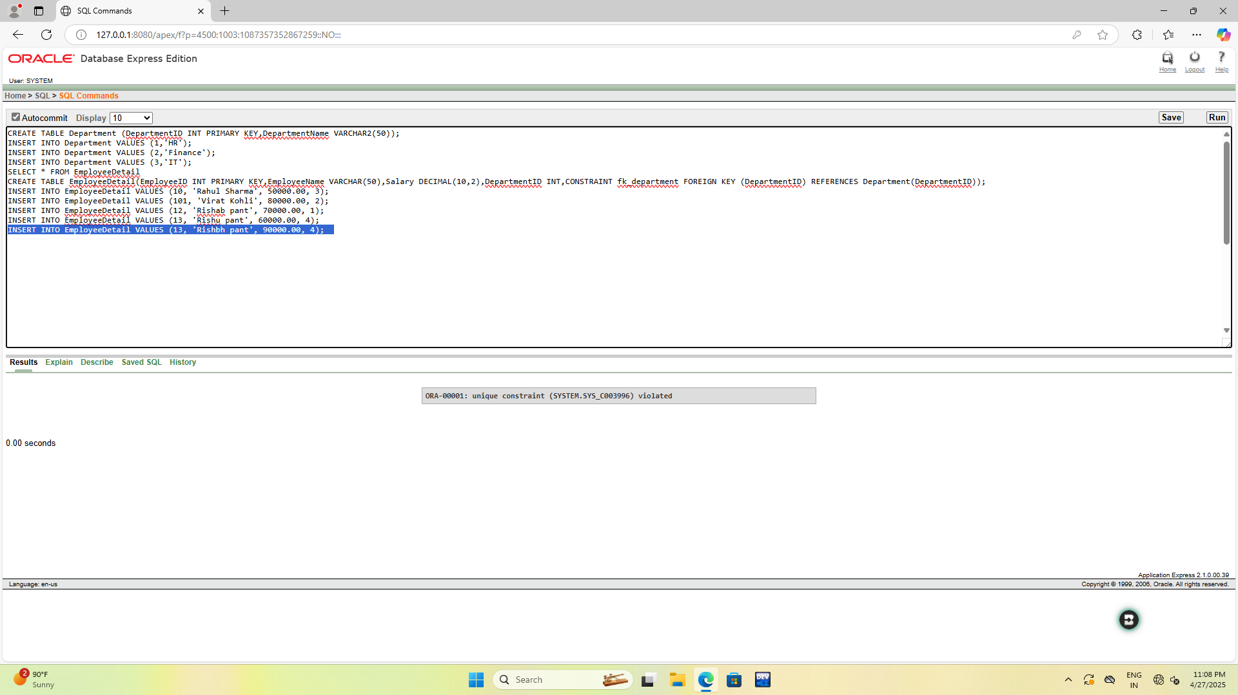
d) Modify the Salary column to have a UNIQUE constraint and attempt to insert two employees with the same salary to test the constraint. 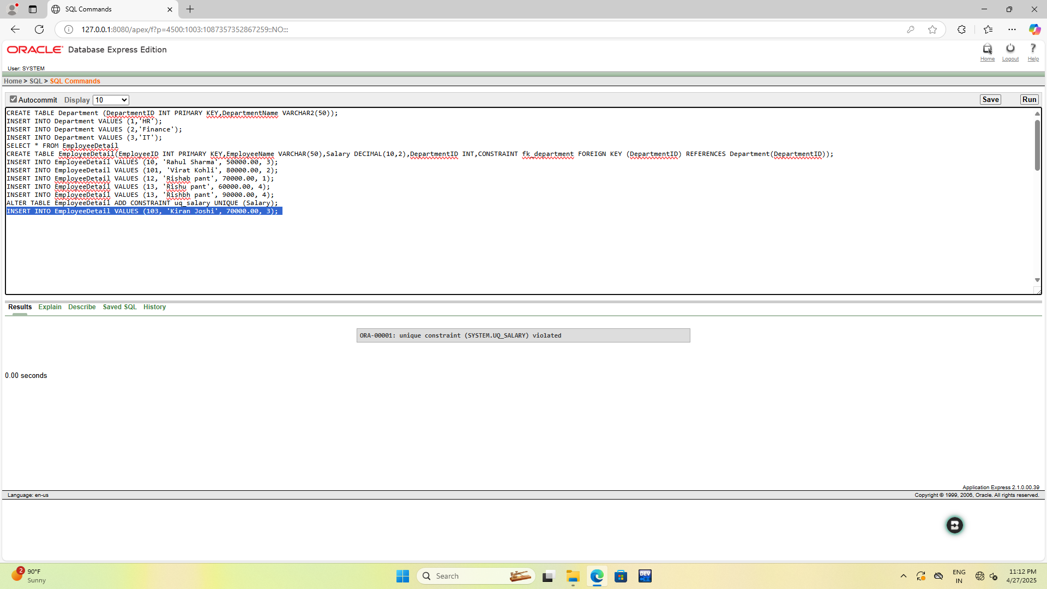
e) Write a query to delete an employee from EmployeeDetails and ensure that the deletion does not violate any referential integrity constraints.